**Hotel Booking & Guest Management System**

**Phase 1**

**👉 Goal:**

Build a Salesforce-based solution for hotels to manage **room bookings, guest check-ins, payments, and staff services**, while ensuring smooth operations and customer satisfaction.

**1. Requirement Gathering**

🔹 Talk to hotel stakeholders (hotel manager, front-desk staff, housekeeping, customers).  
🔹 Example requirements:

* Track all rooms with availability status (vacant, occupied, under maintenance).
* Allow guests to book rooms (via agent or online form).
* Prevent double-booking of the same room.
* Generate invoices automatically at checkout.
* Assign housekeeping/service requests to staff.
* Generate reports: occupancy rate, revenue, service quality.

**2. Stakeholder Analysis**

* **Admin (System Owner):** Sets up Salesforce objects, workflows, and dashboards.
* **Front Desk/Receptionist:** Creates and manages bookings, handles check-in/check-out.
* **Manager:** Approves special requests, views financial and occupancy reports.
* **Housekeeping/Staff:** Receives service tasks (cleaning, maintenance, food delivery).
* **Guest:** End user who books a room, checks in, and avails services.

**3. Business Process Mapping**

📌 Example Flow:  
Guest requests room → Receptionist checks availability → Booking created → Confirmation sent to guest → Guest checks in → Stay & services recorded → Guest checks out → Invoice generated & sent → Feedback recorded.

**4. Industry-Specific Use Case Analysis**

* Rooms have limited availability (must avoid double-bookings).
* Rates vary based on room type, season, and duration.
* Housekeeping & maintenance directly affect guest satisfaction.
* Guest history (loyalty program, preferences) adds business value.
* Revenue tracking is key for hotel profitability.

So, we need to **track rooms, automate bookings & billing, assign staff tasks, and notify guests**.

**5. AppExchange Exploration**

* Some hotel booking & hospitality management apps exist on AppExchange.
* However, we’ll build a **simplified custom Salesforce solution** focusing on **room booking, guest management, and staff coordination**, which is implementable in a short timeframe and tailored to learning Salesforce.

**PHASE 2 – Org Setup & Configuration**

1. **Salesforce Edition**
   * Selected **Developer Edition Org (free)** for building the Hotel Booking & Guest Management System.
2. **Company Profile Setup**
   * Org Name → *Hotel Booking & Guest Management System*
   * Time Zone → Asia/Kolkata (IST)
   * Locale → English (India)
   * Currency → INR

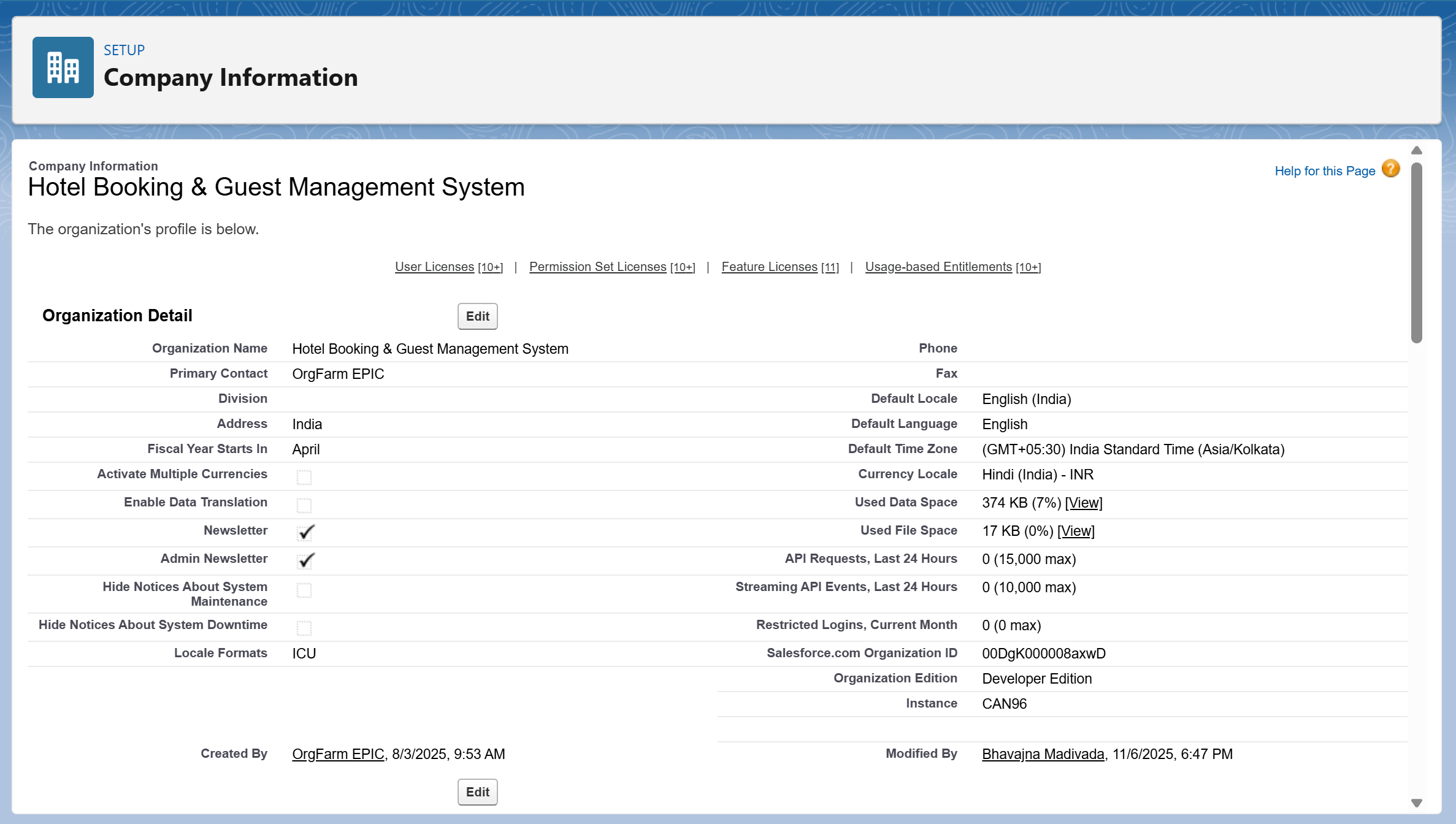

1. **Business Hours & Holidays**
   * Defined working hours → Mon–Sun, 9:00 AM – 9:00 PM (Hotel operational hours)
   * Added holidays like *New Year, Independence Day etc..*
   * Ensures booking and guest management align with hotel business timings

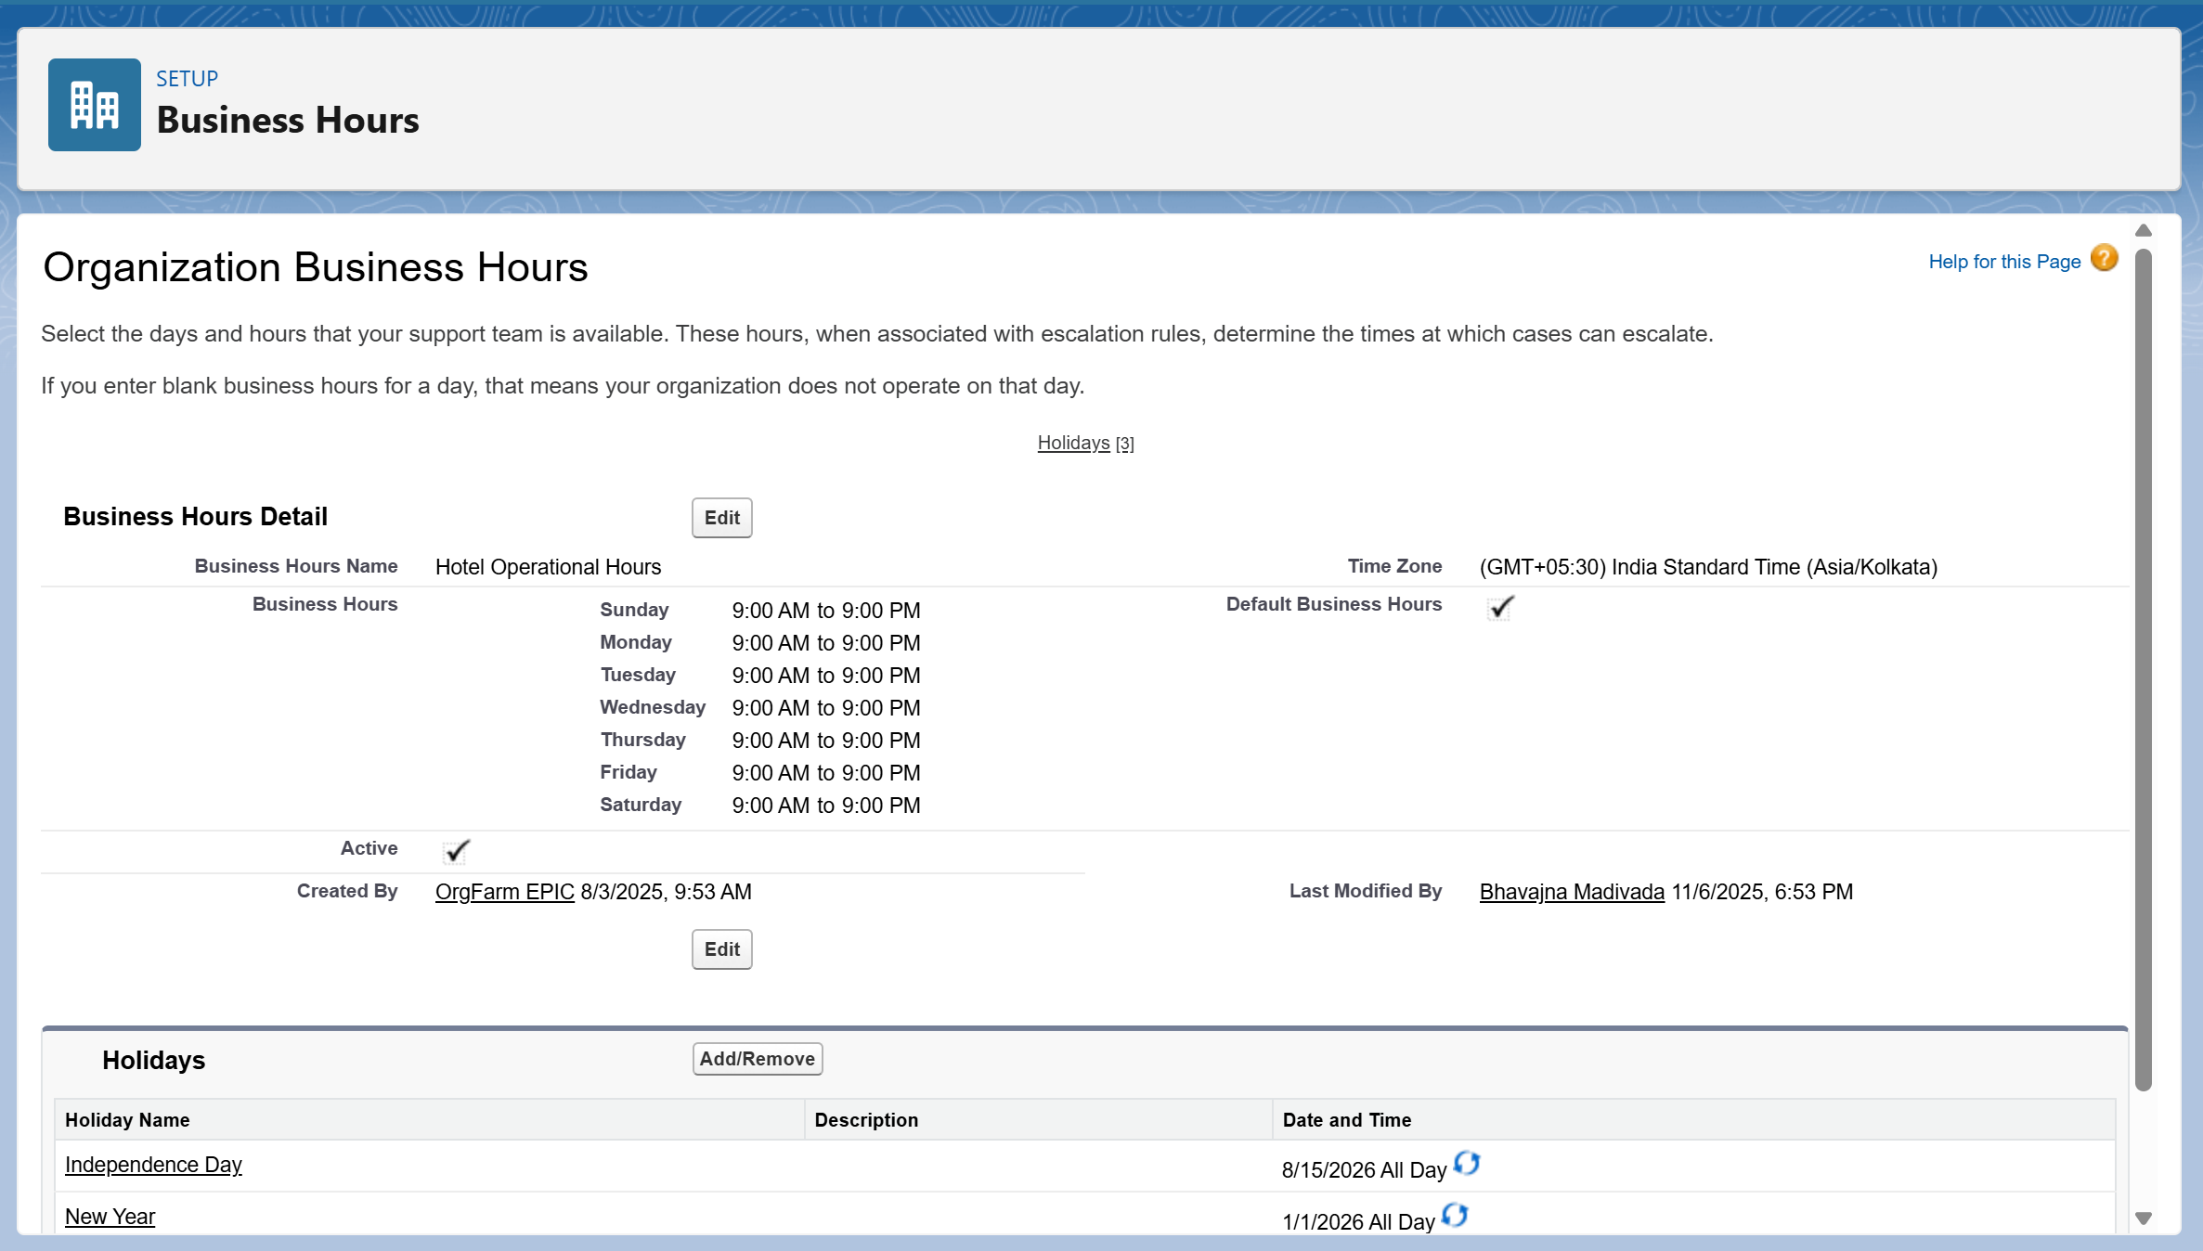

1. **Fiscal Year Settings**
   * Setup → Quick Find: Fiscal Year → Selected **Standard Fiscal Year (Apr–Mar)**

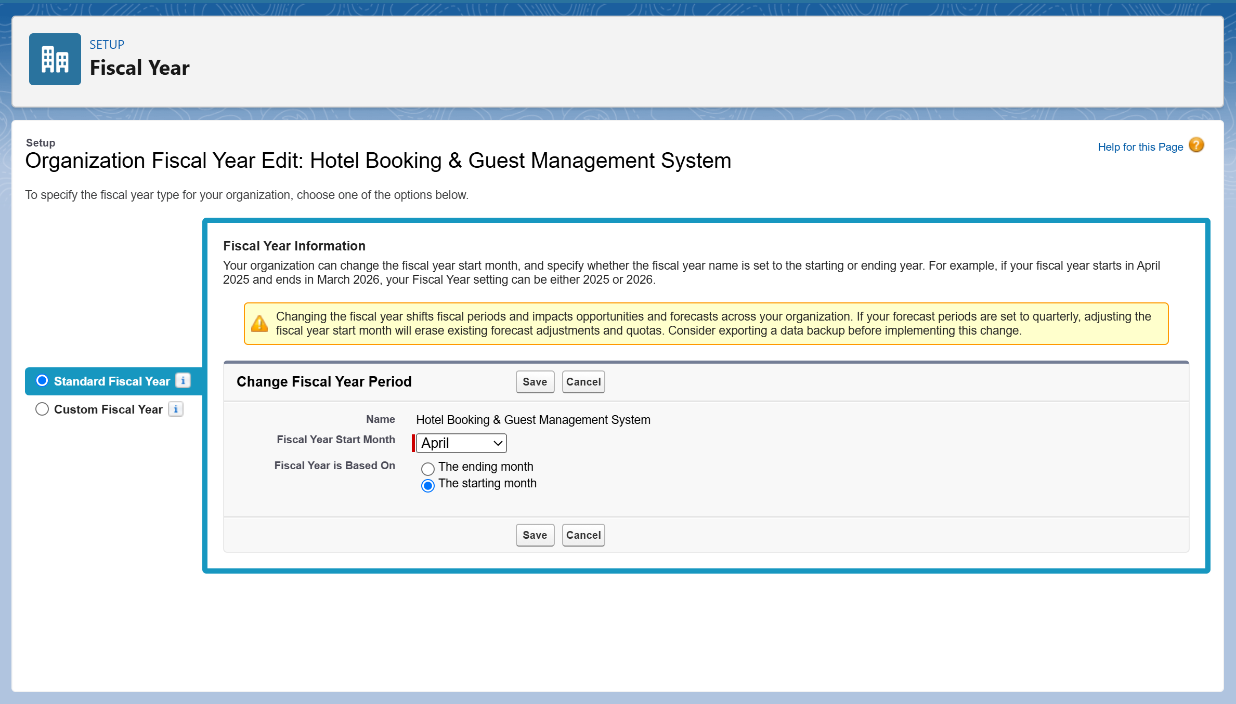

1. **User Setup & Licenses**
   * Created core hotel management users:
     + **Hotel Admin** → Full access (System Admin)
     + **Booking Manager** → Manages reservations and guest records
     + **Front Desk/Receptionist** → Handles walk-in and check-in bookings
     + **Finance User** → Handles billing and invoices
   * Assigned **Salesforce or Salesforce Platform licenses** accordingly

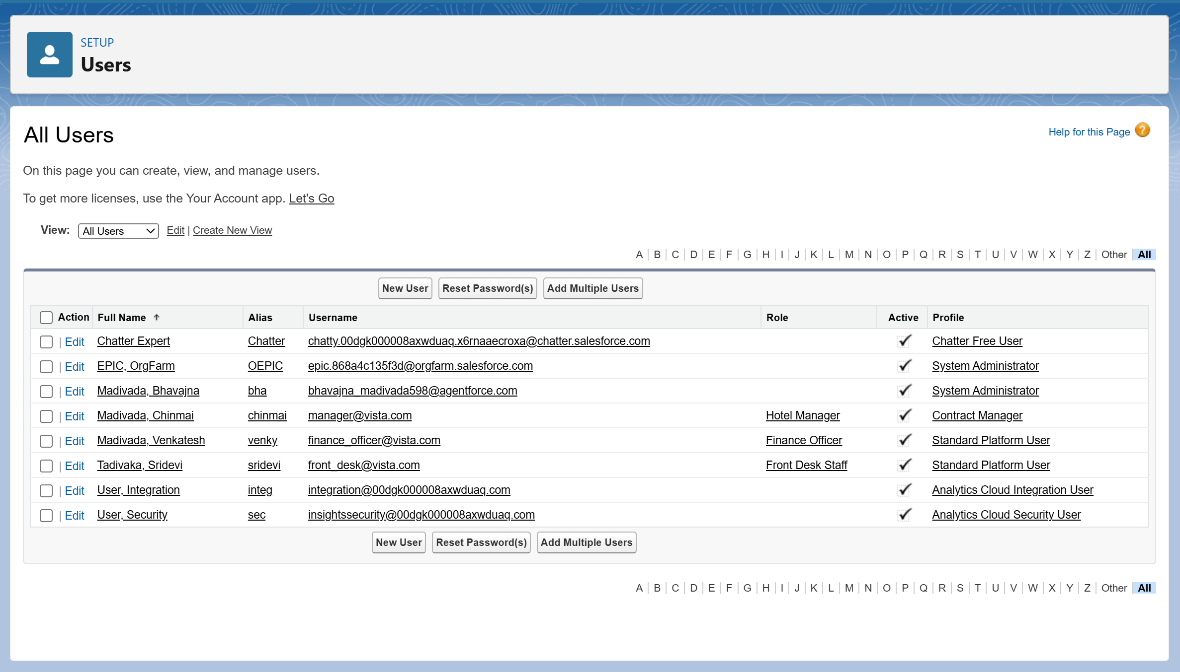

1. **Role Hierarchy**  
   Ensures data visibility and record control based on responsibility levels:
   * Hotel Admin
   * → Booking Manager
   * → Front Desk / Receptionist
   * → Housekeeping staff
   * → Finance User

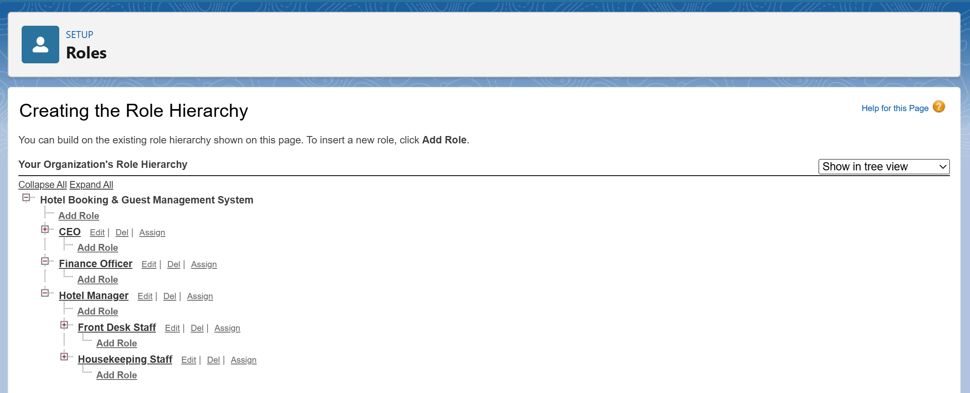

1. **Profiles**
   * **Admin Profile** → for Hotel Admin (Custom)
   * **Booking Manager Profile** → for booking oversight
   * **Front Desk Profile** → for receptionist data entry & limited view
   * **Finance Profile** → for payment/invoice handling
   * Profiles ensure proper object permissions and access boundaries

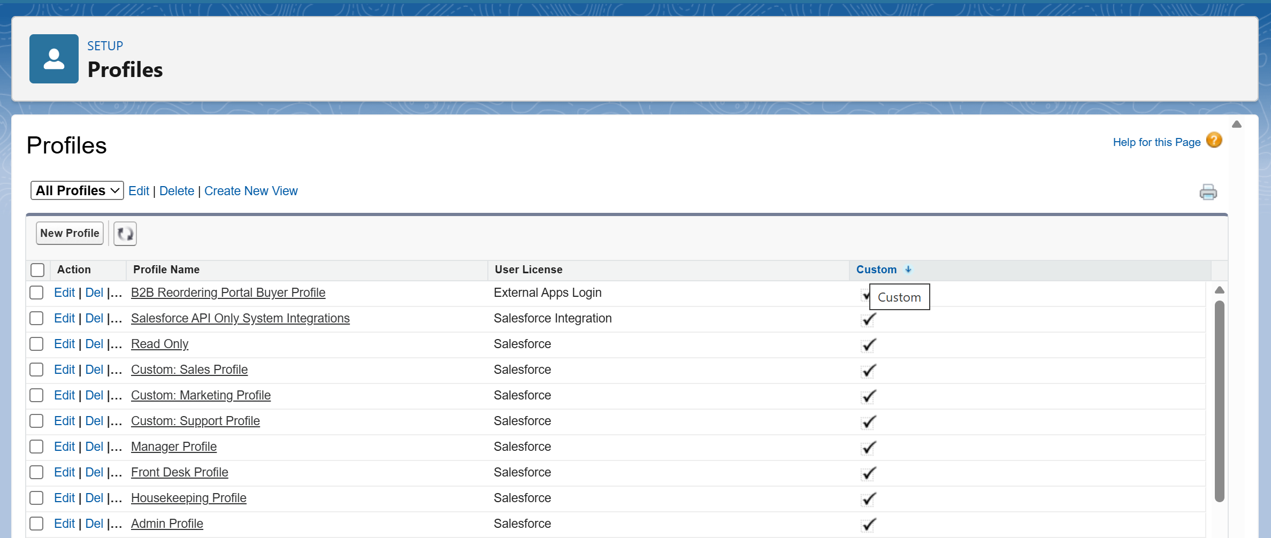

1. **Permission Sets**
   * Created additional permission sets for supplementary access without editing profiles:
     + **Report_Builder_Access** → Create & Customize Reports/Dashboards
     + **Finance_Extended_Access** → Additional access to invoice/payment objects
   * Assigned to respective users based on responsibilities

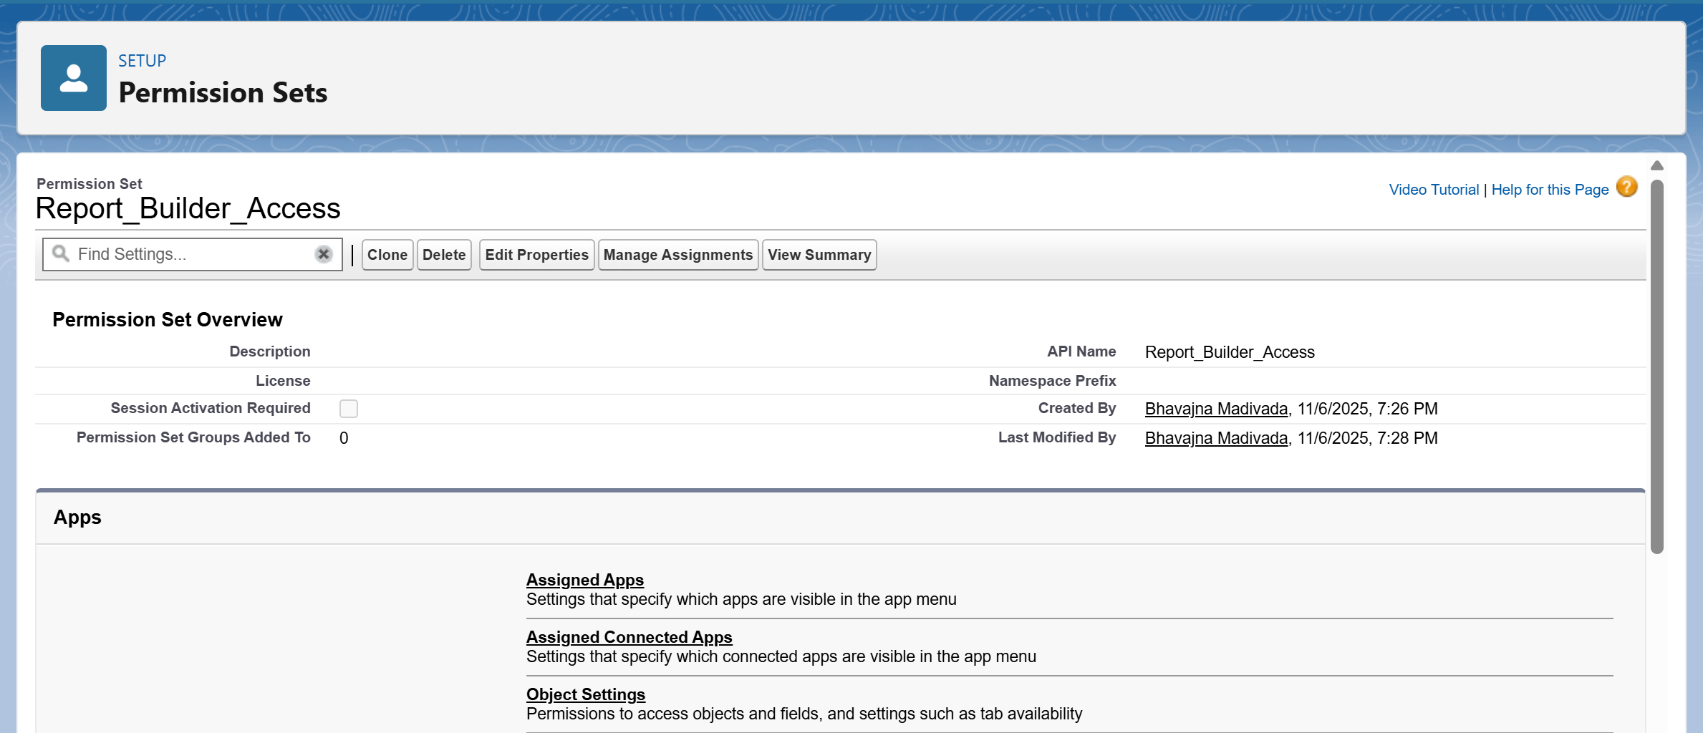

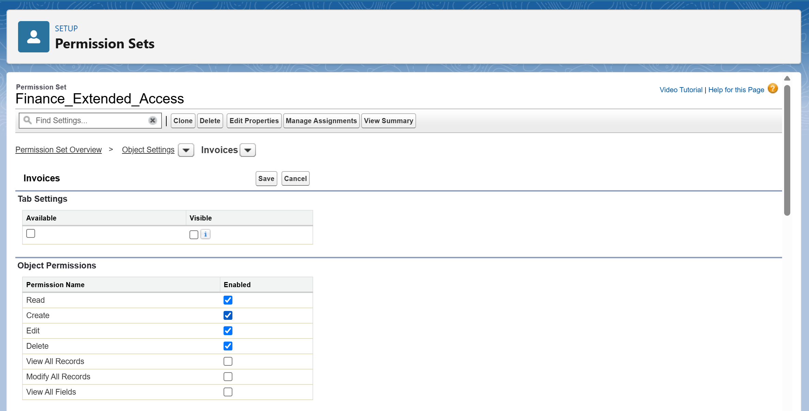

1. **Login Access Policies**
   * Setup → Login Access Policies → Enabled **“Administrators Can Log in as Any User”** for testing and troubleshooting

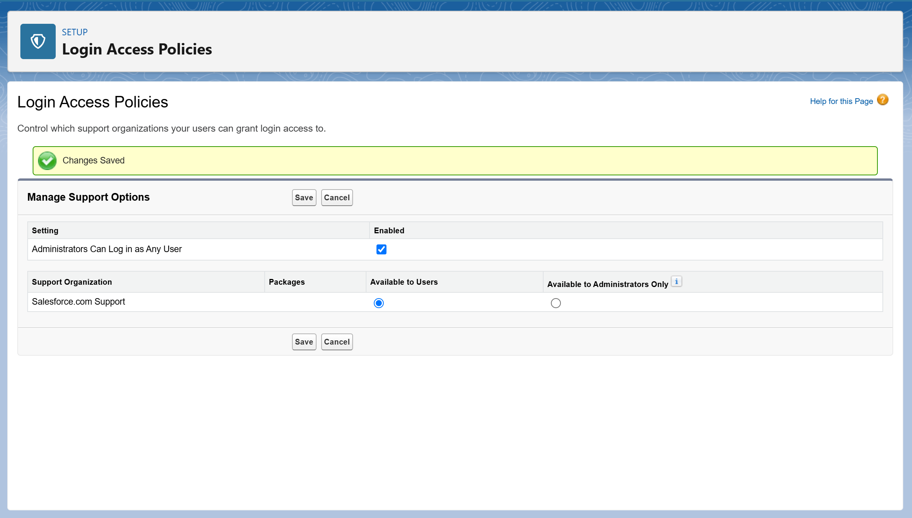

1. **Org-Wide Defaults (OWD) & Sharing Rules**

* Will be configured in **Phase 3**, after custom objects like *Bookings, Guests, Rooms, Invoices* are created

1. **Dev Org Setup & Deployment Basics**

* Salesforce Org connected with **VS Code + SFDX** for development
* Reviewed deployment approaches: **Change Sets, SFDX CLI, and ANT Migration Tool**
* Actual deployments will be handled in **later implementation phases**

**PHASE 3 – Data Modelling & Relationships**

1. **Standard & Custom Objects**
   * Utilized existing **standard objects** like *User* (for hotel staff) and *Account* (for corporate guests or companies).
   * Created the following **custom objects** to handle hotel operations:
     + **Room__c** → Stores room details such as Room Number, Type, and Price.
     + **Guest__c** → Maintains guest information (Name, Contact, ID Proof, etc.).
     + **Booking__c** → Records booking details including check-in, check-out, guest, and room data.
     + **Invoice__c** → Tracks payment details, total amount, and payment status.
     + **Service__c** → Logs extra services like food, spa, or transport availed by guests.
   * All objects were created via **Setup → Object Manager → New Object**.

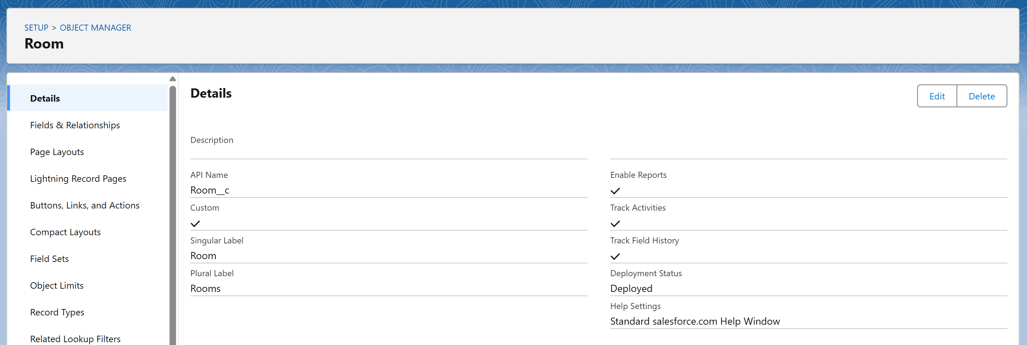

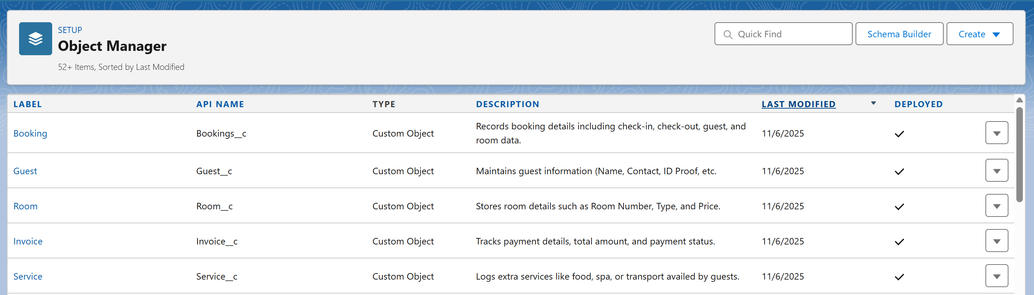

1. **Fields**
   * Added custom fields to capture key hotel data for each object.
   * Example field configurations:

**Room__c**

* + - Room Number (Auto Number)
    - Room Type (Picklist: Single, Double, Suite)
    - Status (Picklist: Available, Booked, Under Maintenance)
    - Price per day (Currency)

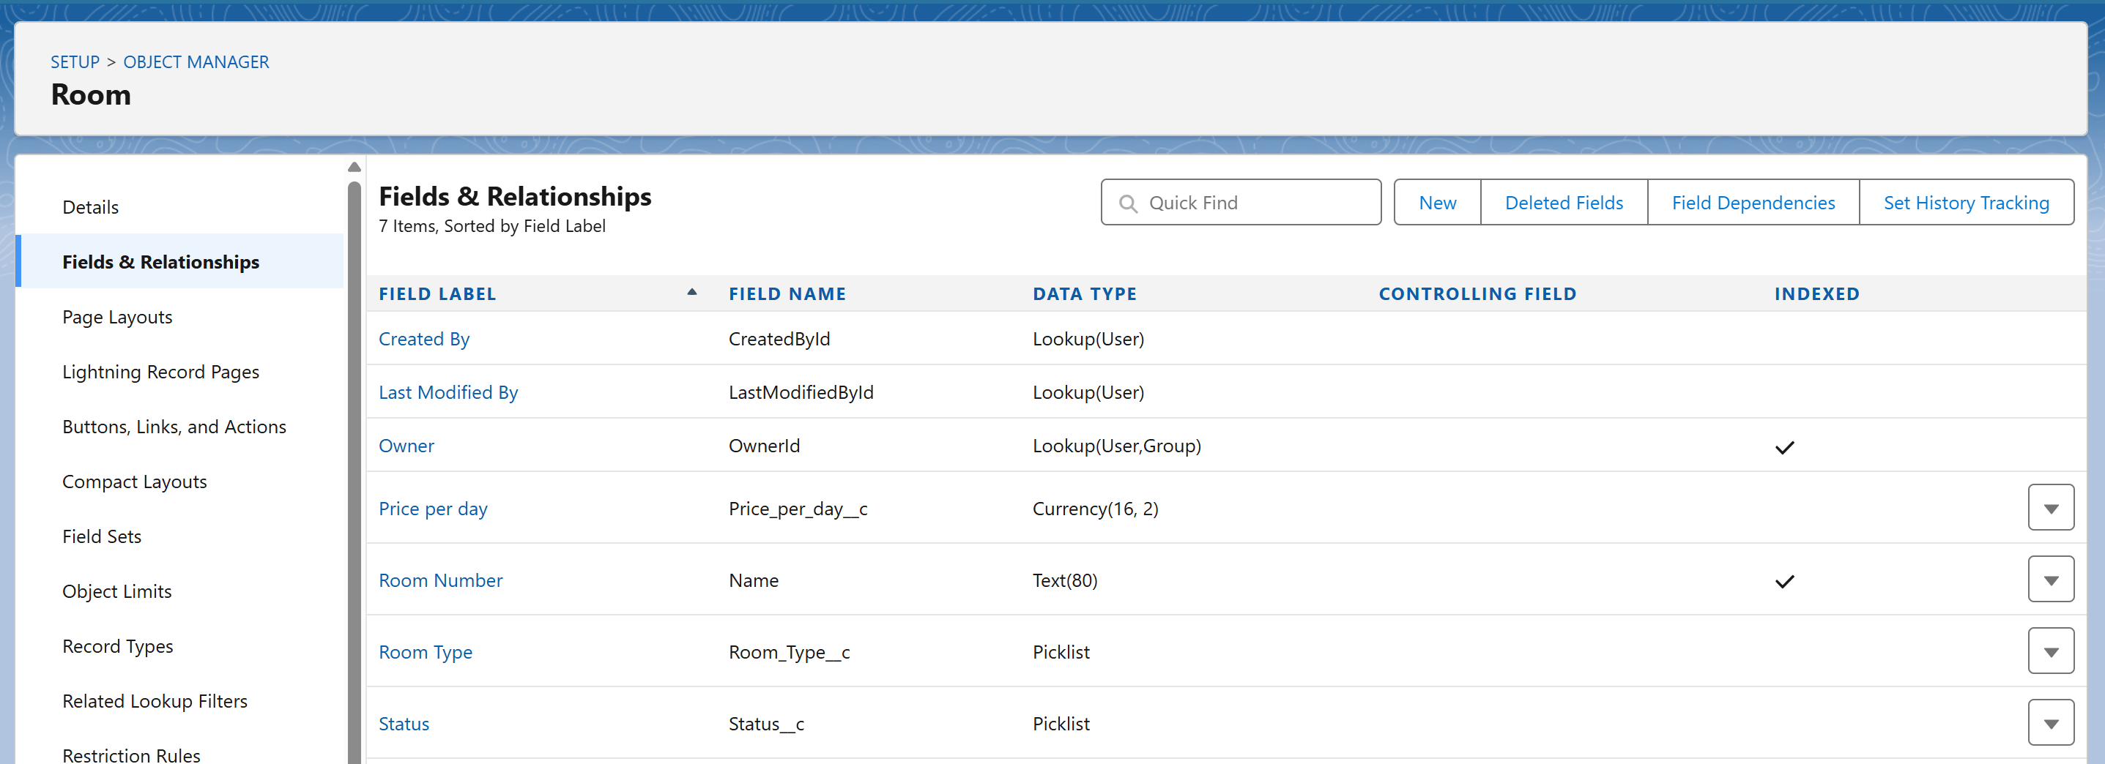

**Guest__c**

* + - Guest Name (Text)
    - Contact Number (Phone)
    - Email (Email)
    - ID_Proof (Picklist: Aadhaar, Passport, PAN)
    - Address (Text Area)

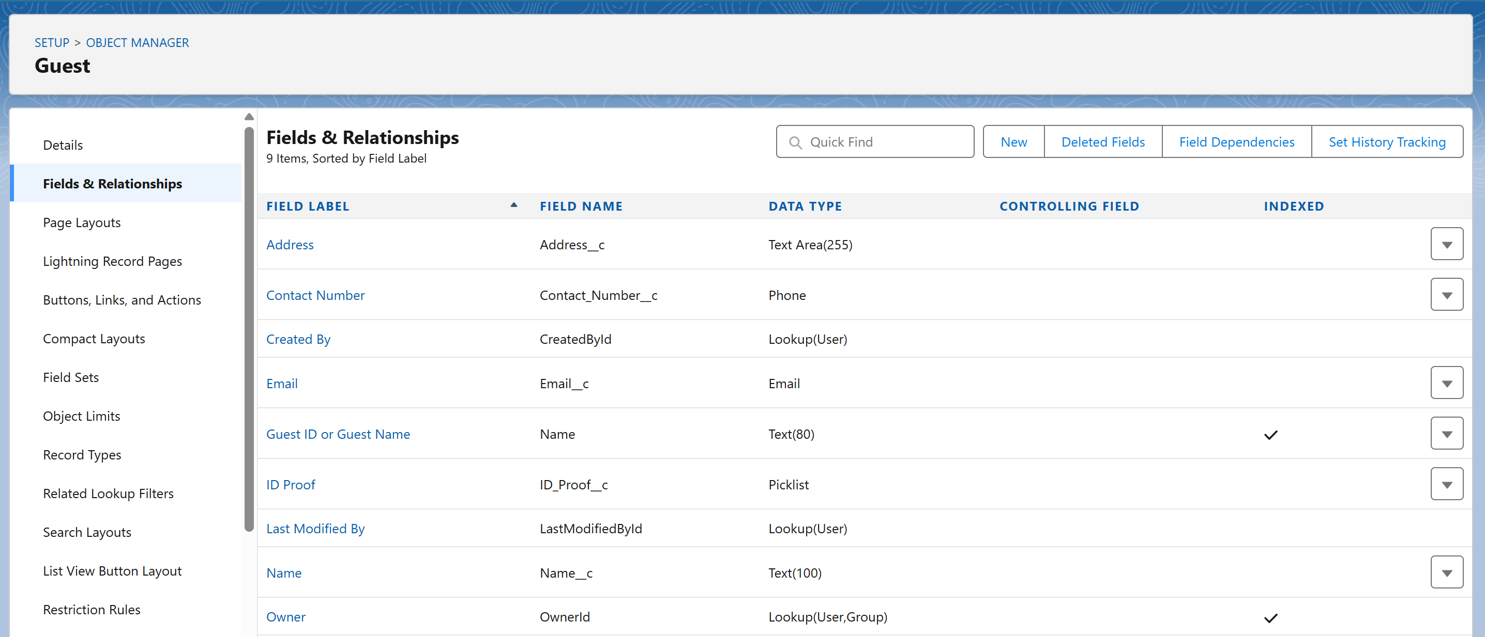

**Booking__c**

* + - Booking_ID (Auto Number)
    - Check_In_Date (Date)
    - Check_Out_Date (Date)
    - Total_Days (Formula)
    - Booking_Status (Confirmed, Checked-In, Checked-Out, Cancelled)
    - Guest (Lookup to Guest__c)
    - Room (Lookup to Room__c)
    - Payment Status (Picklist: Confirmed, Pending, Cancelled)

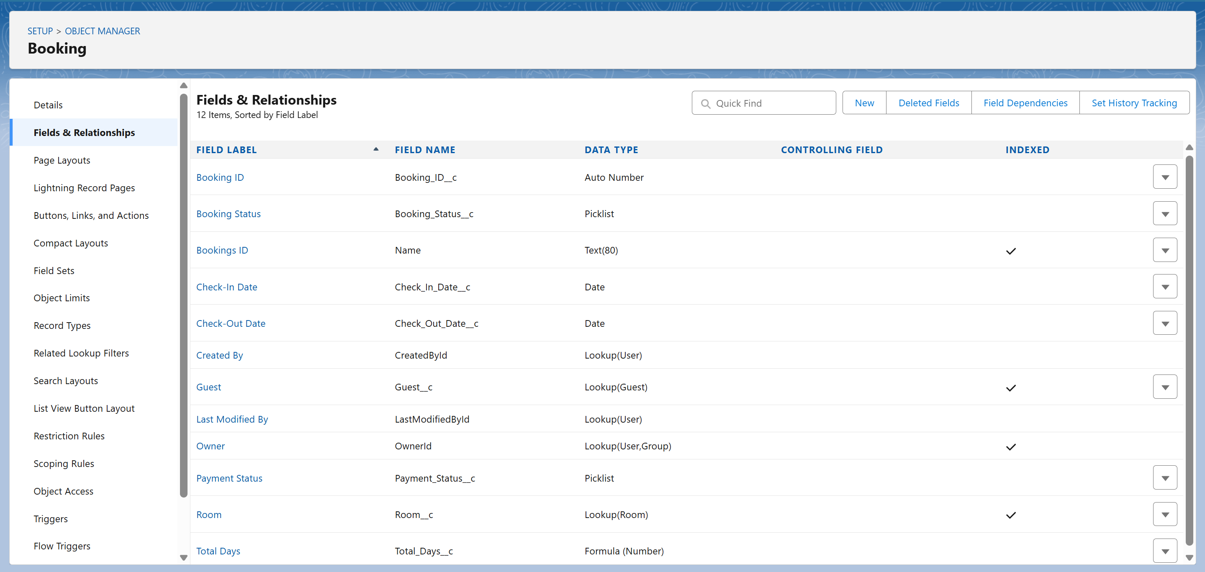

**Invoice__c**

* + - Invoice_Number (Auto Number)
    - Total_Amount (Currency)
    - Payment_Mode (Picklist: Cash, Card, UPI)
    - Booking (Lookup to Booking__c)
    - Payment_Status (Picklist: Paid, Pending)

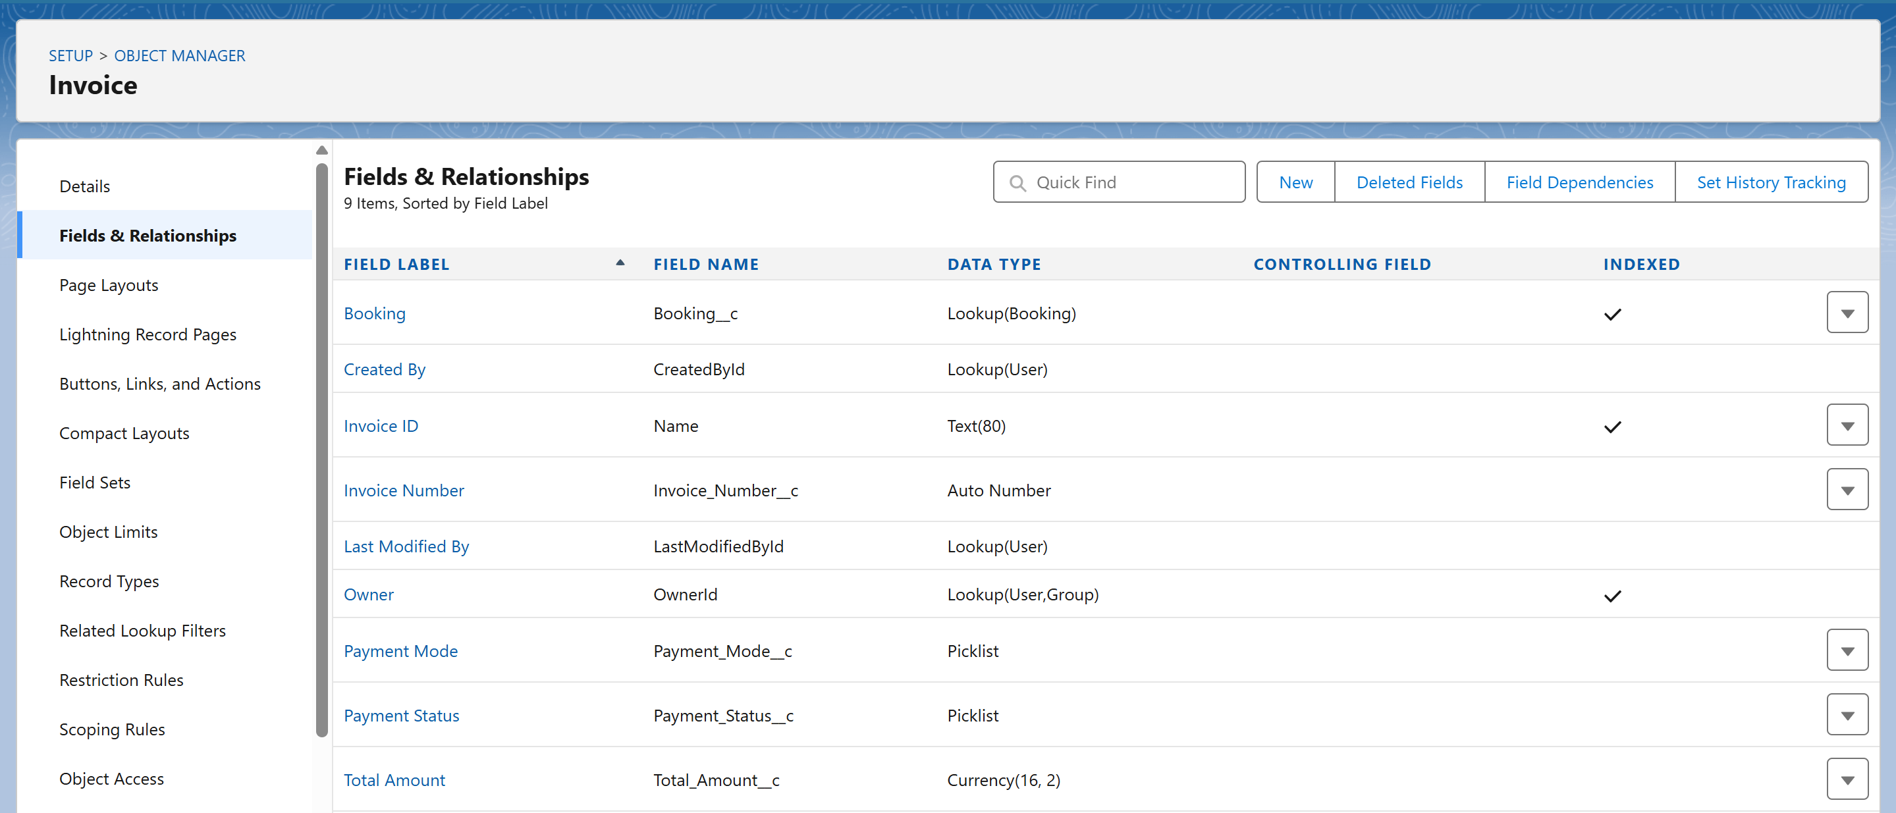

**Service__c**

* + - Service_Name (Picklist: Laundry, Spa, Cab, Food)
    - Service_Charge (Currency)
    - Booking (Lookup to Booking__c)
    - Service_Date (Date)

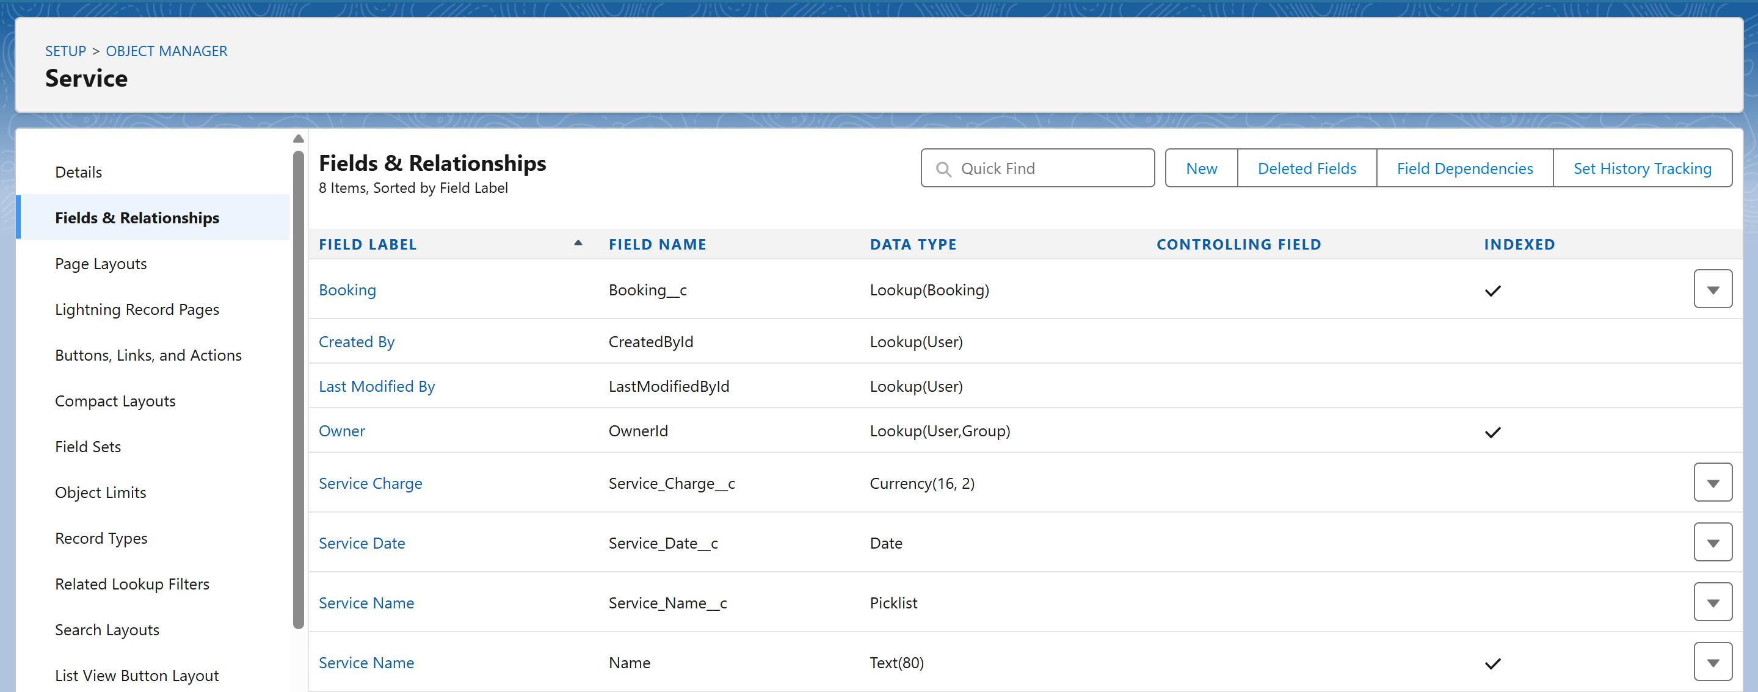

* + Created fields via **Object Manager → [Object Name] → Fields & Relationships → New**.

1. **Record Types**
   * Created record types to separate operations for different booking modes:
     + **Online Booking**
     + **Walk-in Booking**
   * Record types help assign different **page layouts** and **picklist values** for each mode.
   * Navigation: Setup → Object Manager → Booking__c → Record Types → New.

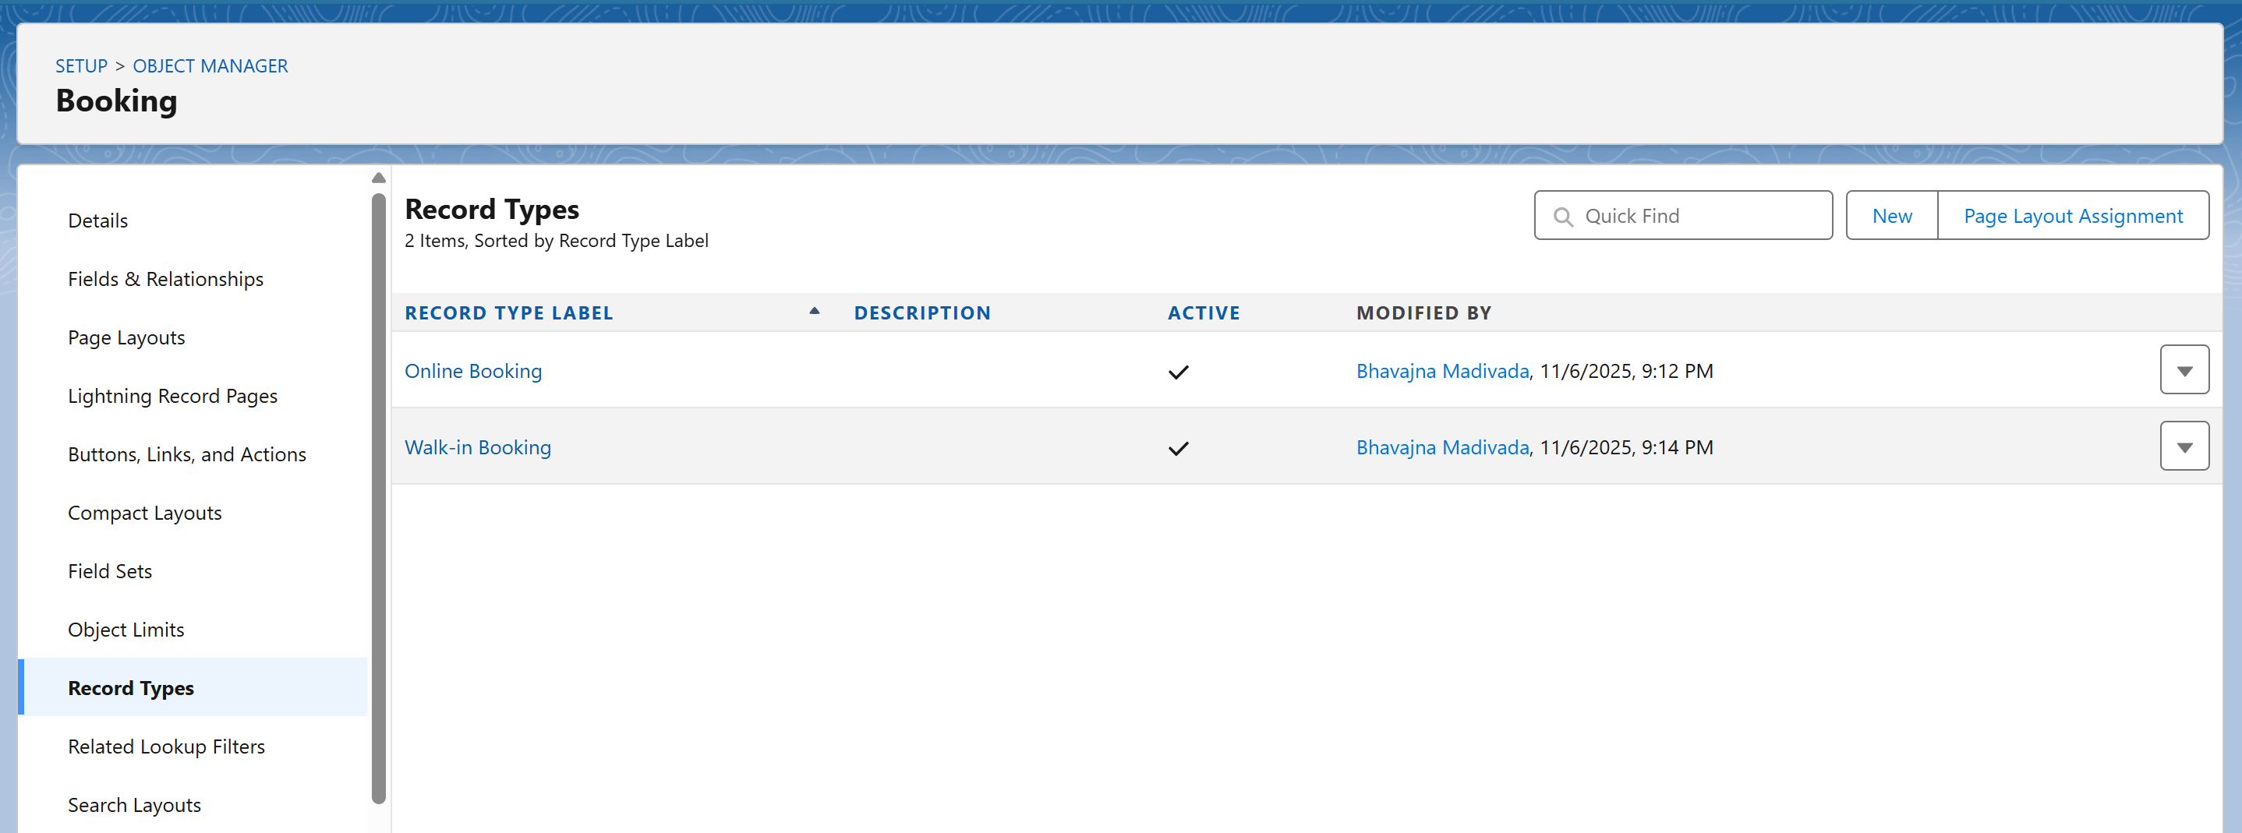

1. **Page Layouts**
   * Designed custom layouts for better usability per user role.
     + **Booking Layout:** Displays Guest, Room, Dates, Status, and Payment.
     + **Guest Layout:** Includes guest personal and contact details.
     + **Invoice Layout:** Shows booking reference and amount details.
   * Added sections like *Guest Info*, *Room Info*, *Billing Details* for easy navigation.
   * Setup → Object Manager → [Object] → Page Layouts → Edit.

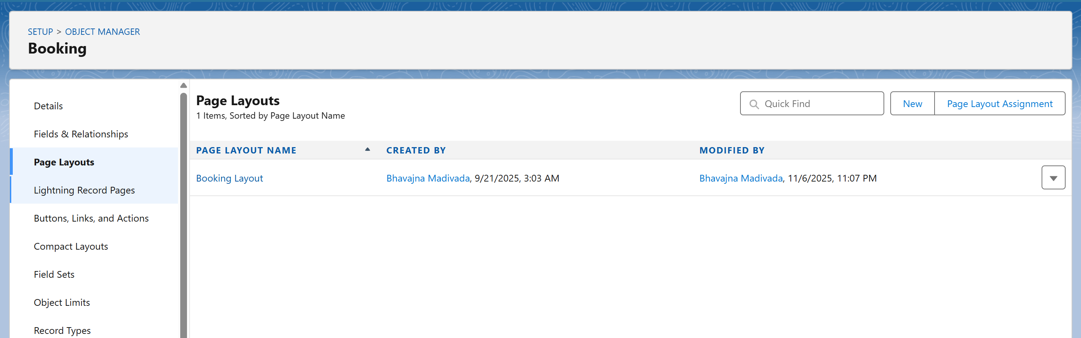

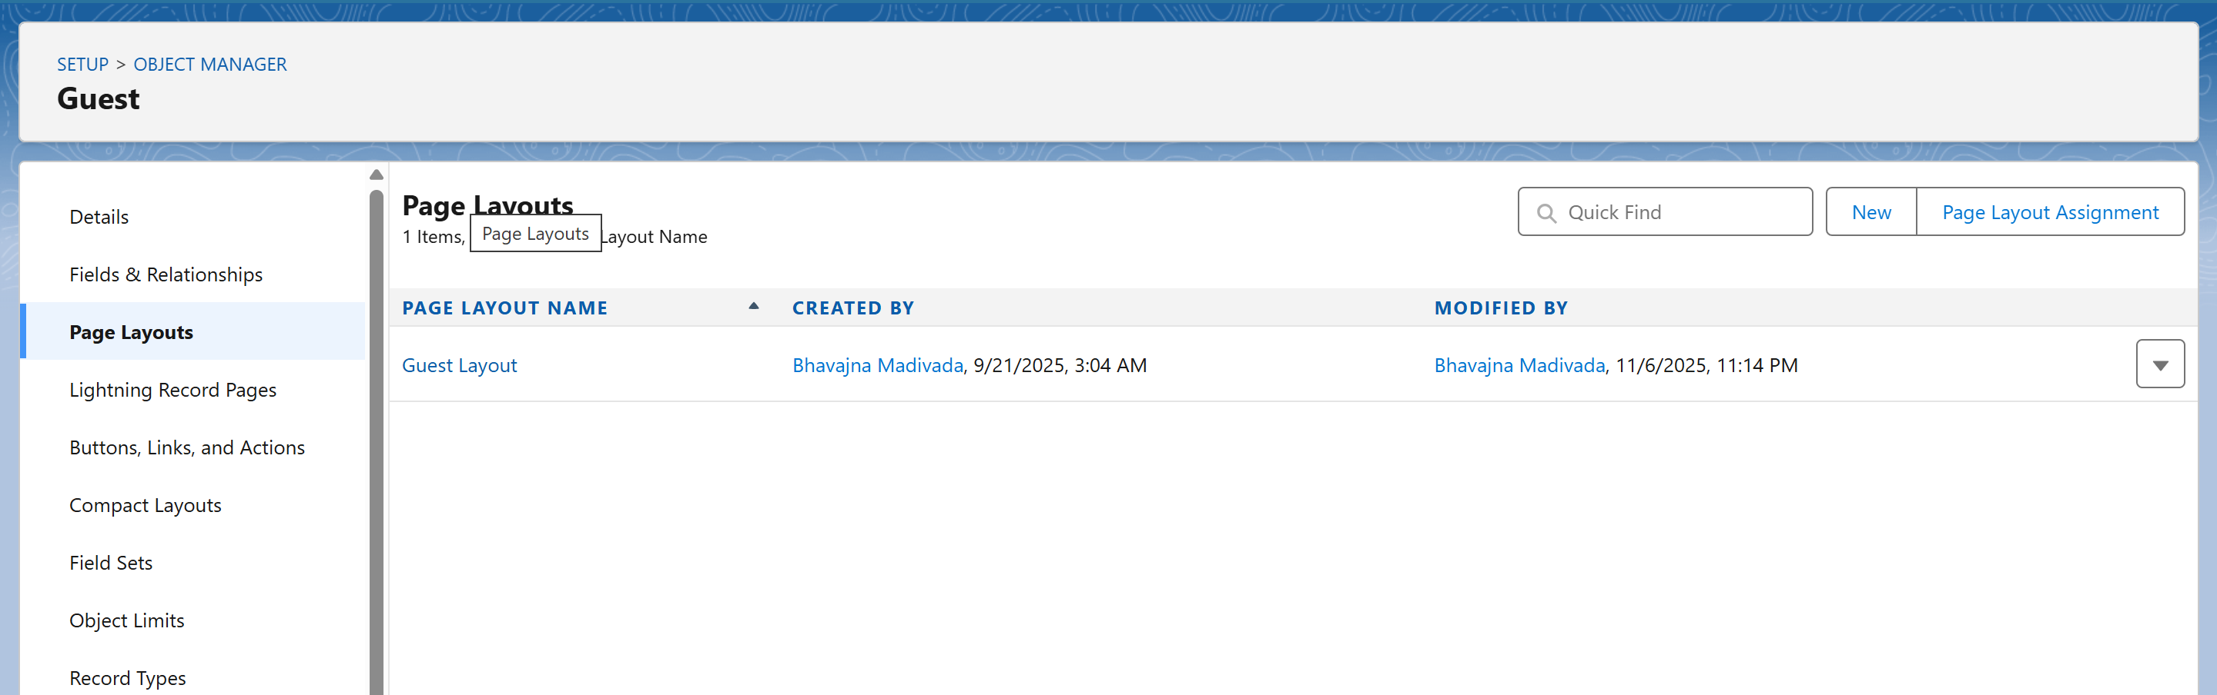

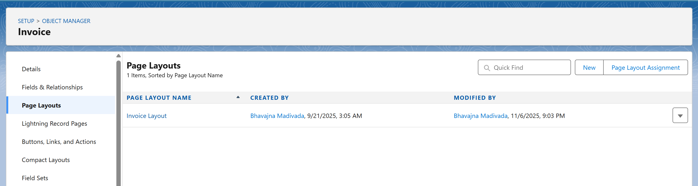

1. **Compact Layouts**
   * Configured compact layouts to show essential fields in record highlights.
     + **Guest Compact Layout:** Guest Name, Phone, Email
     + **Booking Compact Layout:** Booking ID, Guest Name, Room, Booking Status
     + **Invoice Compact Layout:** Invoice Number, Total Amount, Payment Status

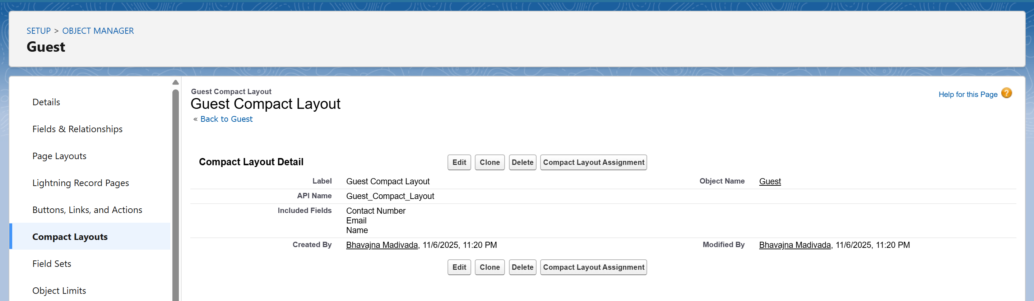

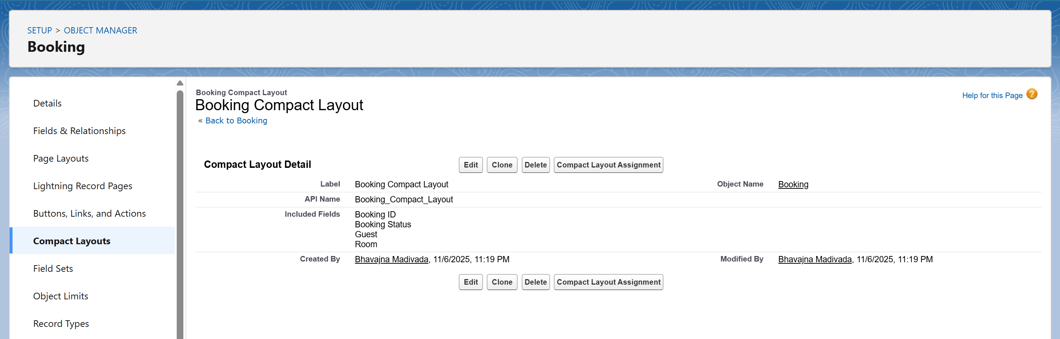

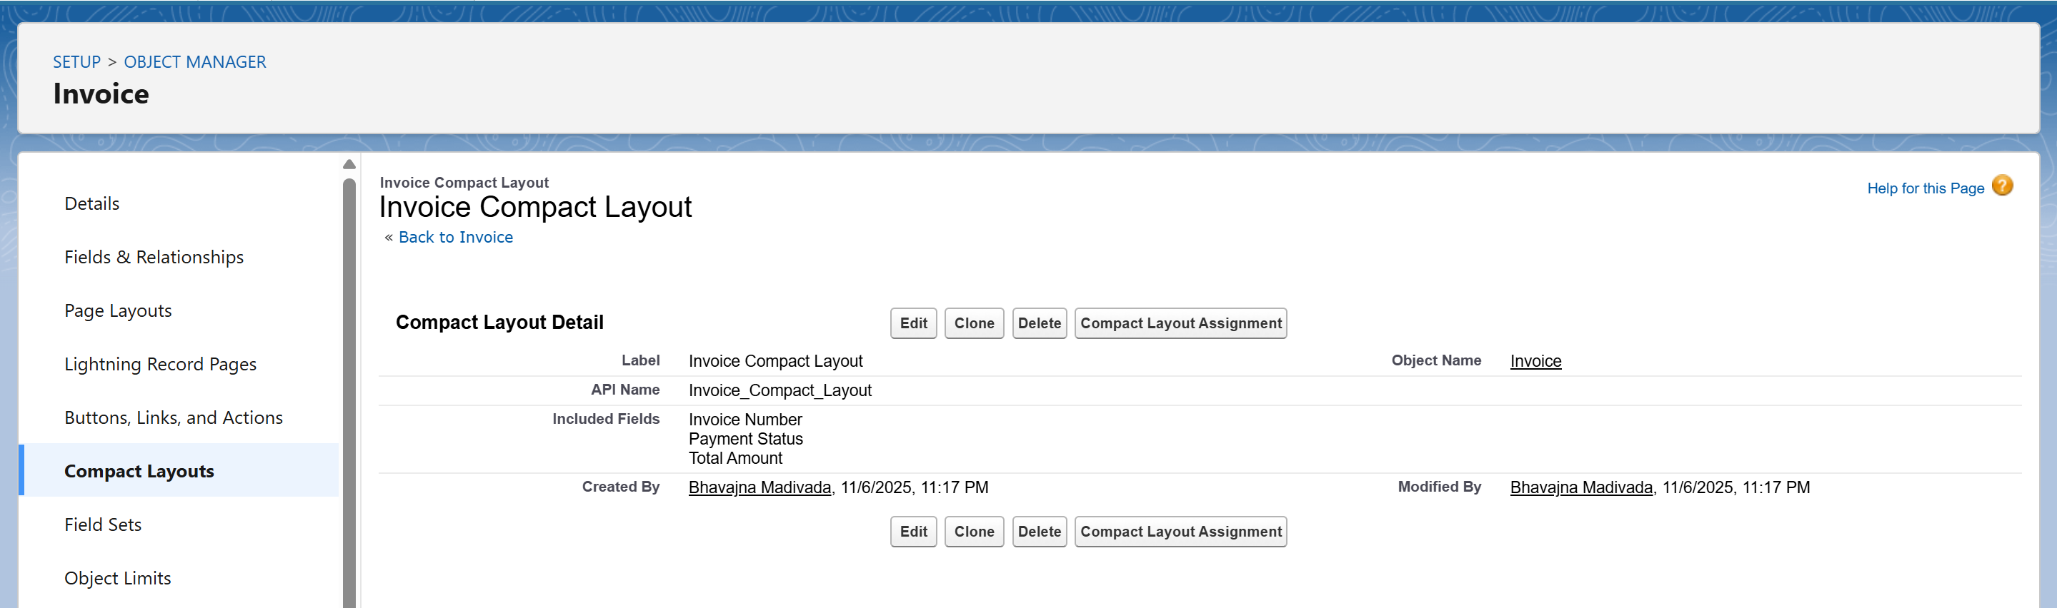

* + Setup → Object Manager → [Object] → Compact Layouts → New → Mark as Primary.

1. **Schema Builder**
   * Opened **Setup → Schema Builder** to visualize object relationships and dependencies.
   * Dragged custom objects like *Room*, *Guest*, *Booking*, *Invoice*, and *Service* onto the canvas.
   * Verified all lookup and master-detail links are correctly connected.
   * Schema Builder helped ensure proper one-to-many and many-to-many relationships.

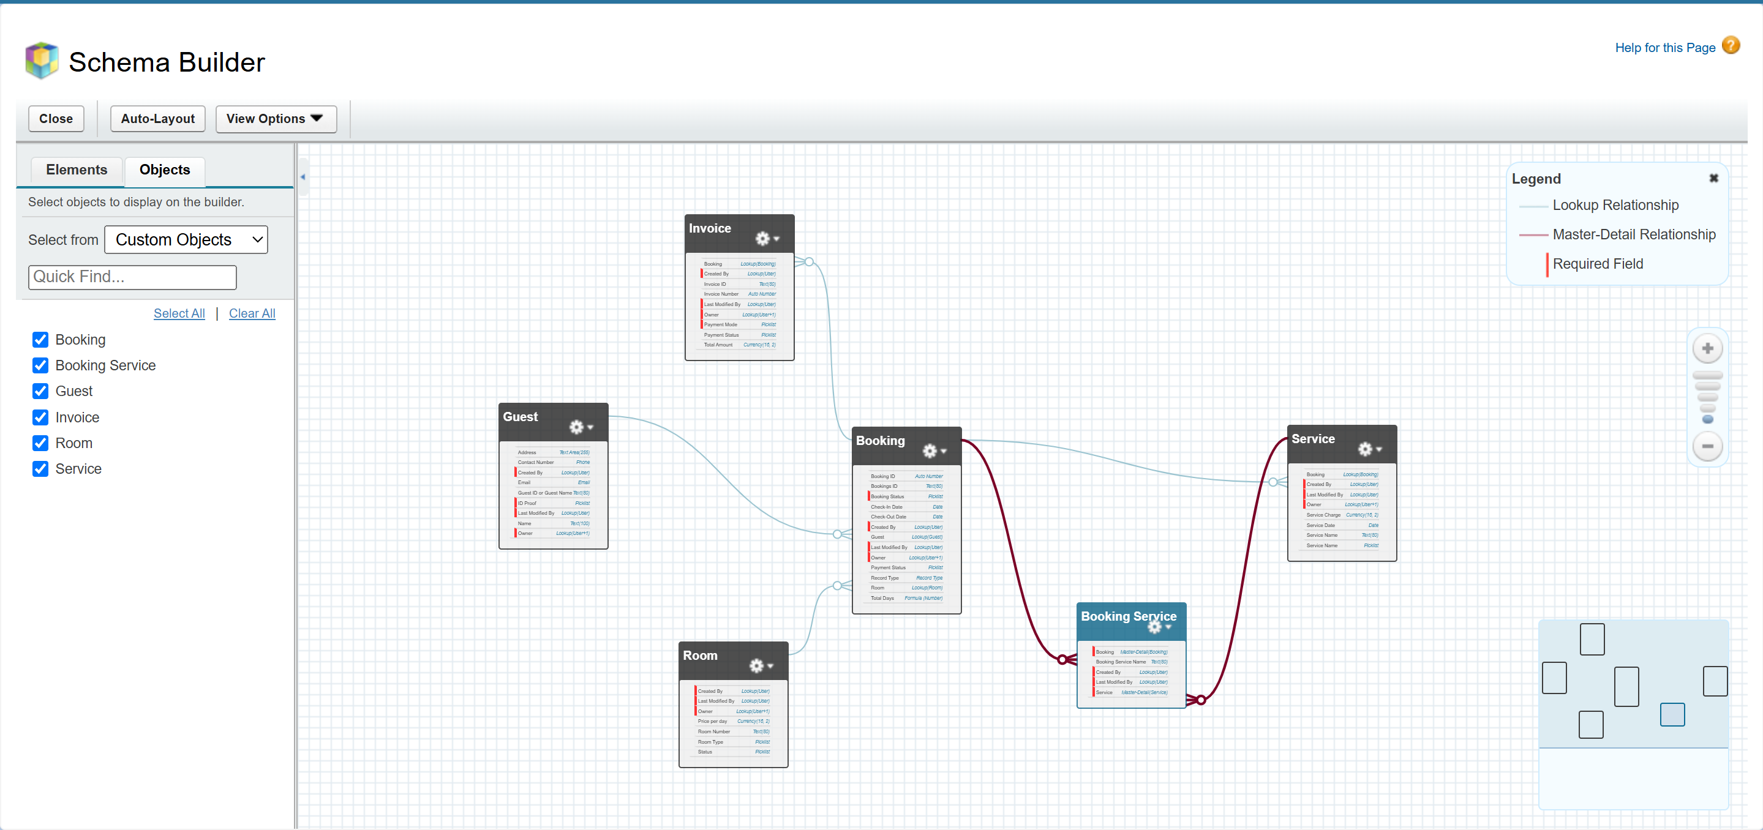

1. **Lookup vs Master-Detail vs Hierarchical Relationships**
   * Used a mix of relationships based on data dependency:
     + **Lookup Relationship:**
       - *Booking → Guest* (A booking is linked to one guest, but a guest can exist without bookings).
       - *Booking → Room* (A booking references one room).
     + **Master-Detail Relationship:**
       - *Invoice → Booking* (Invoice is dependent on the booking; if booking is deleted, invoice is removed).
       - *Service → Booking* (Services tied directly to a specific booking).
     + **Hierarchical Relationship:**
       - Used only for the *User* object (Hotel Admin supervising Managers and Front Desk staff).
2. **Junction Objects**
   * Created a **Booking_Service__c** junction object to manage the **many-to-many relationship** between Bookings and Services.
     + Fields:
       - Booking (Master-Detail to Booking__c)
       - Service (Master-Detail to Service__c)
     + Allows a single booking to include multiple services and one service to be linked to multiple bookings.

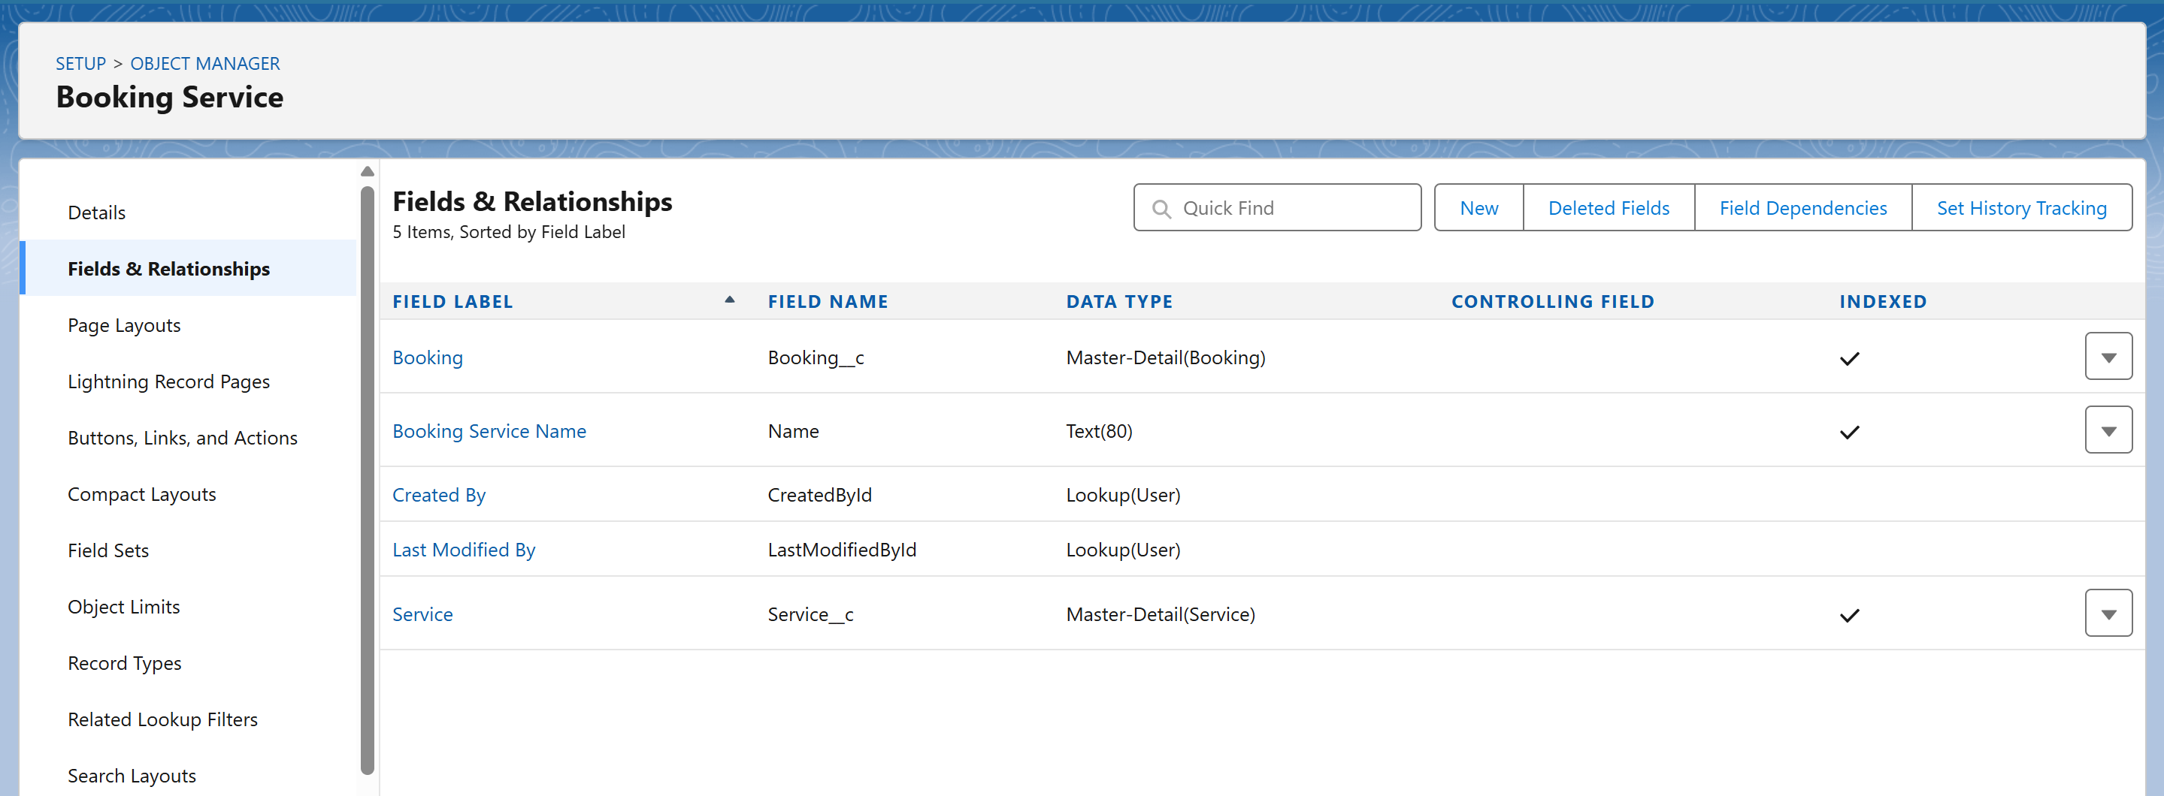

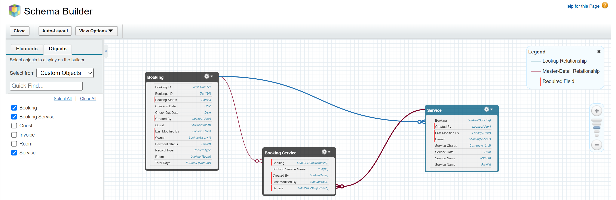

1. **External Objects**
   * External Objects were reviewed but not required for this project scope.
   * Hence, no External Object was created or used.

**PHASE 4 – Process Automation (Admin)**

**1. Validation Rules**

Ensured data accuracy and consistency before saving records.

* **Booking Object:** Prevented check-out date from being earlier than check-in date.  
  **Setup → Object Manager → Booking → Validation Rules → New**
  + Rule Name: *CheckOut_After_CheckIn*
  + Formula: Check_Out_Date__c < Check_In_Date__c
  + Error Message: *"Check-out date must be after check-in date."*
  + Location: *Check-Out Date field*

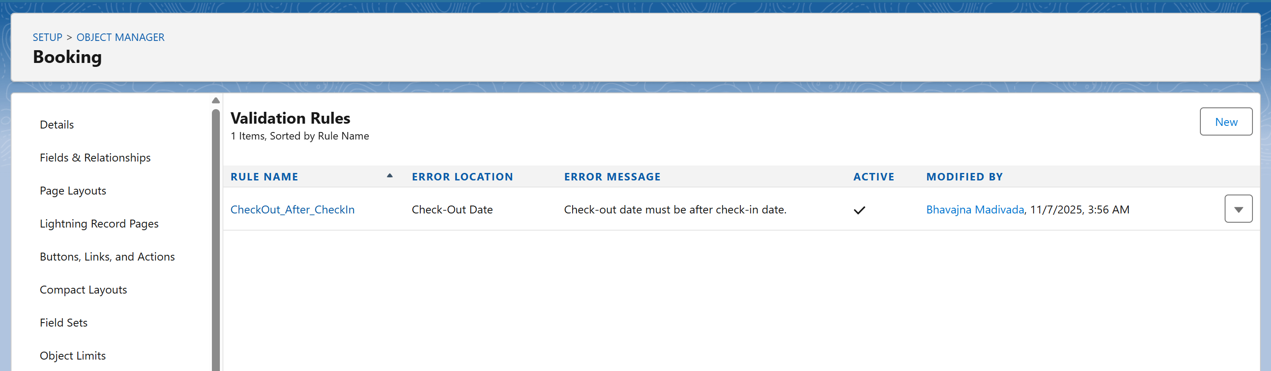

* **Guest Object:** Ensured valid email format before record save.
  + Formula used: NOT(CONTAINS(Email__c, "@"))

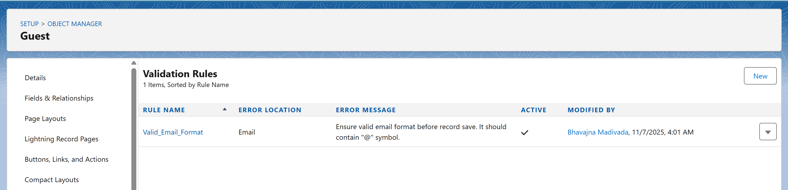

**2. Workflow Rules**

Automated standard actions on record updates.

* **Use Case:** When a booking is marked *Confirmed*, automatically send a confirmation email to the guest.  
  **Setup → Workflow Rules → New Rule**
  + Object: *Booking*
  + Rule Criteria: *Booking Status = Confirmed*
  + Evaluation Criteria: *Created, and every time it’s edited to meet criteria*
  + Action: *Email Alert (Booking Confirmation)*
  + Activated the rule.

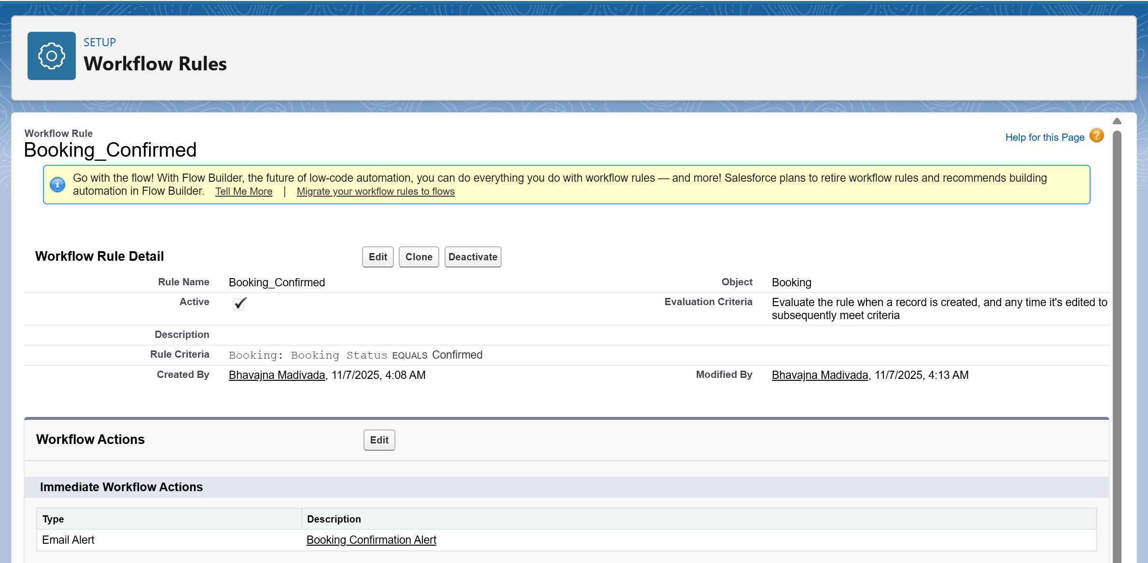

**3. Process Builder** *(Legacy, kept for reference)*

* Explored Process Builder to understand history.
* Not used actively-Flows are the replacement.

**4. Approval Process**

Implemented for room upgrade requests requiring manager approval.  
**Setup → Approval Processes → New → Using Standard Setup Wizard**

* Object: *Booking*
* Entry Criteria: *Room Upgrade Requested = TRUE*
* Approver: *Hotel Manager*
* Final Approval Action: *Update Booking Status → “Approved Upgrade”*
* Final Rejection Action: *Update Booking Status → “Rejected Upgrade”*
* Enabled email notifications for both outcomes.

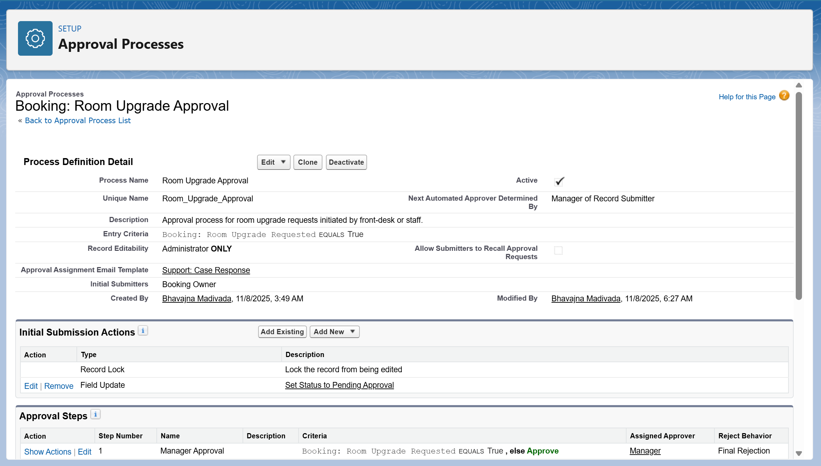

**5. Flow Builder**

Designed multiple flows for automation and user interaction.

**a) Screen Flow – Guest Check-In Form**

* Created an interactive screen to register walk-in guests.
* **Setup → Flow → New Flow → Screen Flow**
* Added input fields: Guest Name, Room, Check-In Date.
* Added *Create Records* element to insert a new Booking.
* Embedded the flow on the *Hotel Front Desk* Lightning Page.

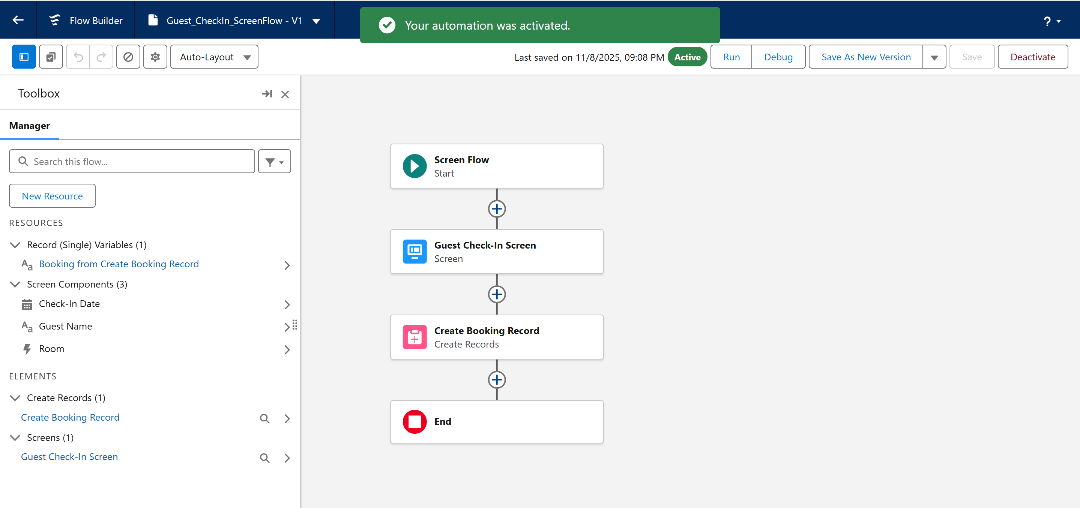

**b) Record-Triggered Flow – Auto-assign Room**

* When a Booking is created, auto-assigns an available room.  
  **Flow Type:** Record-Triggered Flow (on Booking creation)
  + Criteria: *Booking Status = Pending*
  + Action: *Update Booking record → Assign next available Room.*

**c) Scheduled Flow – Booking Reminder Emails**

* Scheduled daily at 8:00 AM to send reminders for next-day check-ins.  
  **Setup → Flow → New → Scheduled-Triggered Flow**
  + Schedule: Daily at 8:00 AM
  + Criteria: *Check-In Date = Tomorrow*
  + Action: *Send Email Alert to Guest.*

**d) Auto-Launched Flow – Update Guest Loyalty Points**

* Triggered via Process Builder whenever a booking completes.
  + Increments guest’s *Loyalty Points* based on total booking amount.

**6. Email Alerts**

* Configured email templates for:
  + **Booking Confirmation**
  + **Room Upgrade Approval/Rejection**
  + **Payment Receipt**
* **Setup → Email Alerts → New**
  + Selected template and recipient fields (Guest Email).
  + Linked to Workflow and Flow actions.

**7. Field Updates**

* Used inside workflows to update status automatically.
  + **Example:** When payment received → *Payment Status = Paid*
  + **Setup → Workflow Actions → Field Update → New**
  + Selected Booking object and set field value.

**8. Tasks**

* Created automatic follow-up tasks for staff after guest check-out.
  + **Setup → Workflow → Add Workflow Action → New Task**
  + Assigned to: *Housekeeping Role*
  + Subject: *“Clean and Prepare Room for Next Guest”*
  + Due Date: *1 day after check-out date.*

**9. Custom Notifications**

* Configured Salesforce custom notifications for front-desk and finance staff.
  + **Setup → Notification Builder → Custom Notifications → New**
  + Name: *Booking Alert*
  + Assigned to App: *Hotel Management App*
  + Used in Flow to send instant alerts when high-value booking (> ₹10,000) is created.
  + Users receive a pop-up notification in Salesforce and mobile app.